**Unsupervised Learning**

Features:

|  |  |  |  |  |
| --- | --- | --- | --- | --- |
| Features | Min | Max | Mean | Std. Dev |
| Account_age | 3 | 3650 | 1061.662 | 976.434 |
| Average_links | 0 | 4 | 0.806 | 0.777 |
| Average minutes between posts | 0 | 80628.667 | 3266.506 | 7289.987 |
| Average post length | 0 | 33 | 13.729 | 5.731 |
| Average posts per day active days | 1 | 49.353 | 1.142 | 0.69 |
| Average posts per day total | 0 | 2712 | 37.541 | 122.712 |
| Average user mentions | 0 | 7 | 0.753 | 0.674 |
| Boost score average | 0 | 9.138 | 0.028 | 0.032 |
| Boost score std dev | 0 | 0.068 | 0.006 | 0.016 |
| Boost score sum | 0 | 0.32 | 0.035 | 0.042 |
| Boosting timeslots count | 0 | 3 | 0.294 | 0.474 |
| Count authors sharing boosted posts | 0 | 2915 | 690.601 | 1185.737 |
| Default profile | 0 | 1 | 0.575 | 0.494 |
| Default profile image | 0 | 1 | 0.03 | 0.171 |
| Friends followers ratio | 0 | 398 | 15.227 | 35.667 |
| Listed count | 0 | 30555 | 77.733 | 435.378 |
| Number of followers | 0 | 2934956 | 3306.058 | 43944.801 |
| Number of friends | 0 | 271104 | 1064.389 | 4738.953 |
| Number of crawled posts | 1 | 839 | 1.63 | 8.835 |
| Number of posts | 0 | 2660984 | 27247.153 | 77530.947 |
| Number of pointed posts | 1 | 375 | 1.571 | 5.755 |
| Number pointers | 1 | 381 | 1.615 | 6.167 |
| Topic net betweeness centrality | 0 | 0.131 | 0.006 | 0.014 |
| Topic net betweeness centrality aggregation function kurt neighb size 1 | 0 | 25.967 | 25.037 | 4.829 |
| Topic net betweeness centrality aggregation function kurt neighb size 2 | 0 | 25.967 | 25.037 | 4.829 |
| Topic net betweeness centrality aggregation function mean neighb size 1 | 0 | 0.006 | 0.006 | 0.002 |
| Topic net betweeness centrality aggregation function mean neighb size 2 | 0 | 0.006 | 0.006 | 0.002 |
| Topic net betweeness centrality aggregation function skew neighb size 1 | 0 | 4.613 | 4.363 | 1.019 |
| Topic net betweeness centrality aggregation function skew neighb size 2 | 0 | 4.613 | 4.363 | 1.019 |
| Topic net betweeness centrality aggregation function std neighb size 1 | 0 | 0.015 | 0.013 | 0.004 |
| Topic net betweeness centrality aggregation function std neighb size 2 | 0 | 0.015 | 0.013 | 0.004 |
| Topic net closeness centrality | 0.001 | 0.224 | 0.153 | 0.059 |
| Topic net closeness centrality aggregation function kurt neighb size 1 | -6 | 0 | -0.986 | 0.4 |
| Topic net closeness centrality aggregation function kurt neighb size 2 | -6 | 0 | -0.986 | 0.4 |
| Topic net closeness centrality aggregation function mean neighb size 1 | 0.001 | 0.167 | 0.153 | 0.046 |
| Topic net closeness centrality aggregation function mean neighb size 2 | 0.001 | 0.167 | 0.153 | 0.046 |
| Topic net closeness centrality aggregation function skew neighb size 1 | -0.488 | 0.391 | -0.456 | 0.134 |
| Topic net closeness centrality aggregation function skew neighb size 1 | -0.488 | 0.391 | -0.456 | 0.134 |
| Topic net clustering | 0 | 1 | 0.738 | 0.318 |
| Topic net clustering aggregation function kurt neighb size 1 | -6 | 1.549 | 1.453 | 0.647 |
| Topic net clustering aggregation function kurt neighb size 2 | -6 | 1.549 | 1.453 | 0.647 |
| Topic net clustering aggregation function mean neighb size 1 | 0 | 1 | 0.738 | 0.15 |
| Topic net clustering aggregation function mean neighb size 2 | 0 | 1 | 0.738 | 0.15 |
| Topic net clustering aggregation function skew neighb size 1 | -1.599 | 1.208 | -1.498 | 0.442 |
| Topic net clustering aggregation function skew neighb size 2 | -1.599 | 1.208 | -1.498 | 0.442 |
| Topic net clustering aggregation function std neighb size 1 | 0 | 0.416 | 0.273 | 0.07 |
| Topic net clustering aggregation function std neighb size 2 | 0 | 0.416 | 0.273 | 0.07 |
| Topic net degree centrality | 0.001 | 0.201 | 0.055 | 0.054 |
| Topic net degree centrality aggregation function kurt neighb size 1 | -6 | 0 | -1.125 | 0.413 |
| Topic net degree centrality aggregation function kurt neighb size 2 | -6 | 0 | -1.125 | 0.413 |
| Topic net degree centrality aggregation function mean neighb size 1 | 0.001 | 0.06 | 0.055 | 0.016 |
| Topic net degree centrality aggregation function mean neighb size 2 | 0.001 | 0.06 | 0.055 | 0.016 |
| Topic net degree centrality aggregation function skew neighb size 1 | 0 | 0.857 | 0.483 | 0.102 |
| Topic net degree centrality aggregation function skew neighb size 2 | 0 | 0.857 | 0.483 | 0.102 |
| Topic net degree centrality aggregation function std neighb size 1 | 0 | 0.054 | 0.05 | 0.015 |
| Topic net degree centrality aggregation function std neighb size 2 | 0 | 0.054 | 0.05 | 0.015 |
| verified | 0 | 1 | 0.008 | 0.087 |

**Visualization**:

1. Account age

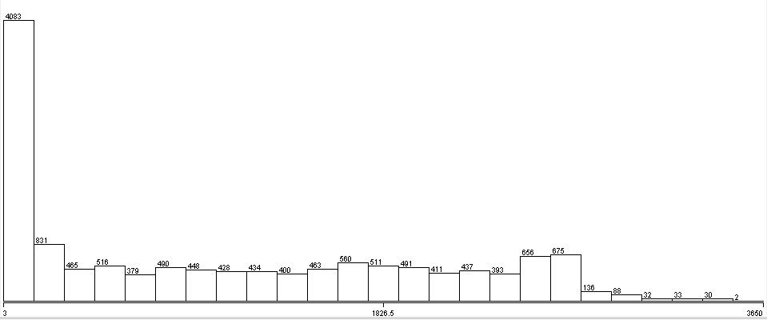

1. Average links

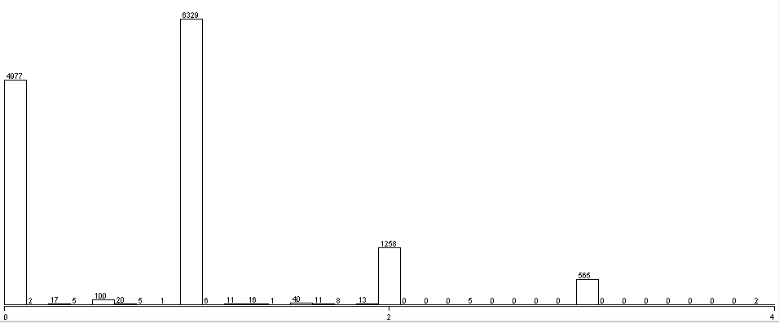

1. Average post length

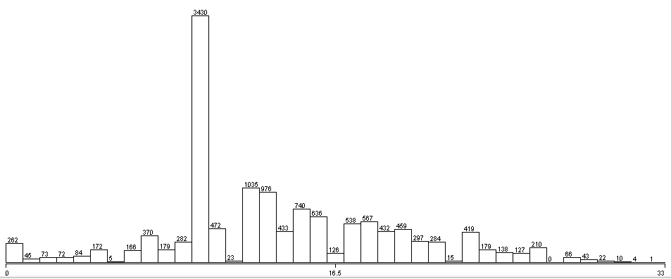

1. Boost score average

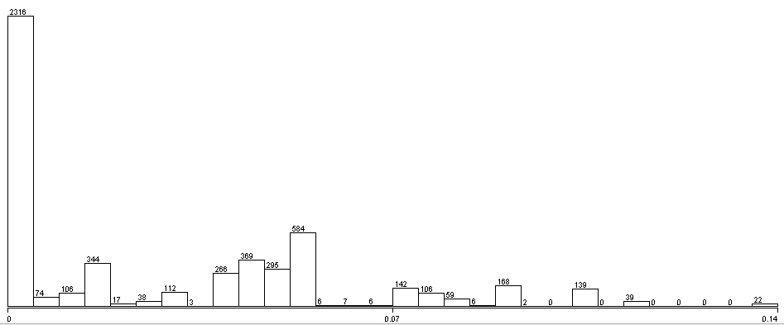

1. Boost score std dev

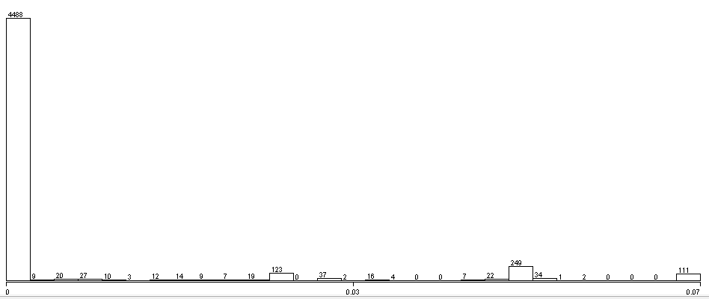

1. Count authors sharing boosted posts

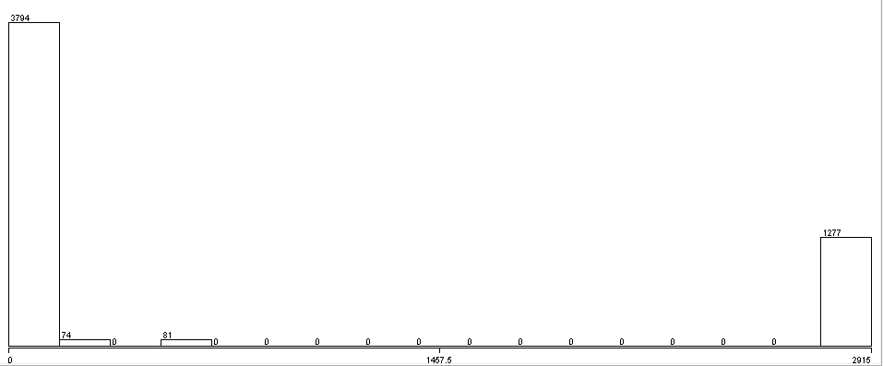

1. Default profile

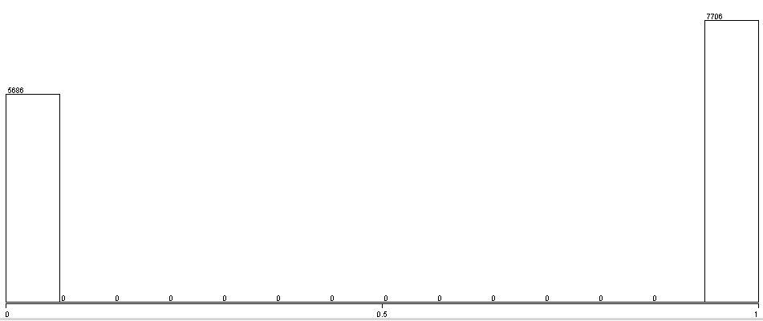

1. Topic net closeness centrality

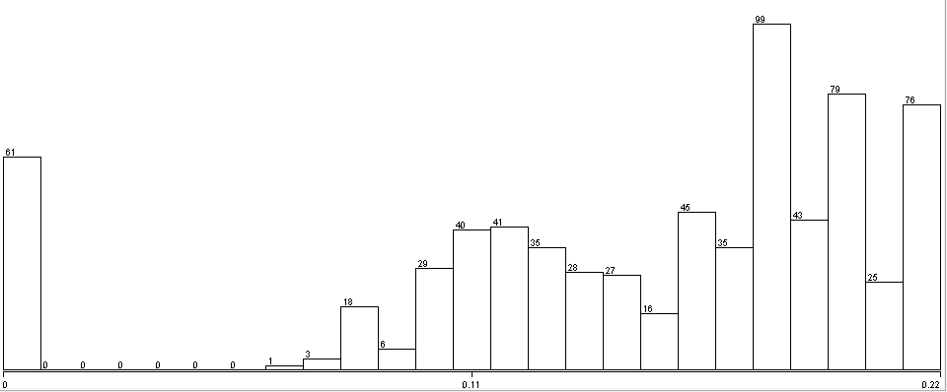

1. Topic net clustering

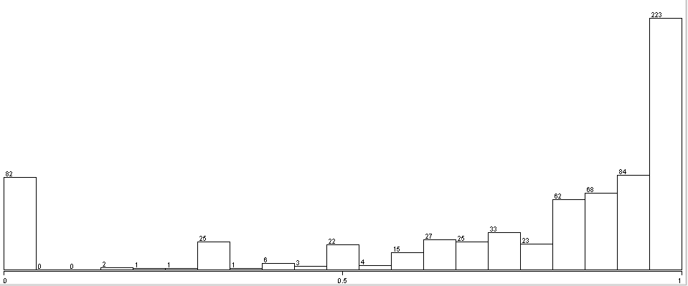

1. Topic net degree centrality

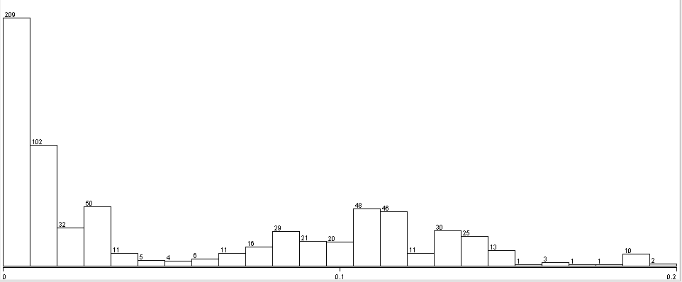

מבחינת קלאסטרים:

נקבל 3 קלאסטרים באמצעות EM :

Cluster0 – 12,209 - 91%

Cluster 1 – 958 – 7%

Cluster2- 225 – 2%